Software Requirements Specification

for

JUOSTA

**Version 1.1**

**26/2/2021**

**Table of Contents**

**Introduction (Section: 30%)** **1**

Product Scope (15%) 1

Document Conventions (5%) 2

Intended Audience and Reading Suggestions (Bonus : 1 Grade Scale for this section) 2

References (10%) 3

**Overall Description (Section : 25%)** **5**

Product Perspective (15%) 5

Product Functions (Bonus : 1 Grade Scale for this section) 6

User Classes and Characteristics (5%) 7

Assumptions and Dependencies (5%) 7

**External Interface Requirements (Section : 5%)** **8**

User Interfaces (5%) MENUS 8

**System Features (Section : 40%)** **9**

Game Controller 9

Render Component 9

Transform Component 10

Behaviour Component 10

Physics Component 11

Collision Component 11

Pathfinding 12

Procedural Map Generation System 12

Shield Bash 13

Lifeline System 13

Ultimate Skill System 14

Shop/Upgrade/Gun Augments System 14

**Appendix A: Glossary** **16**

**Appendix B: Analysis Models** **17**

**<Optionally, include any pertinent analysis models, such as data flow diagrams, class diagrams, state-transition diagrams, or entity-relationship diagrams.>** **17**

**Appendix C: To Be Determined List** **18**

**Revision History**

|  |  |  |  |
| --- | --- | --- | --- |
| **Name** | **Date** | **Reason For Changes** | **Version** |
| Amirul | 2 6/2/2021 | New member, latest update on game | 1.1 |
| Amirul | 12/4/2021 | Final Changes for the game | 1.2 |

# Introduction (Section: 30%)

## Product Scope (15%)

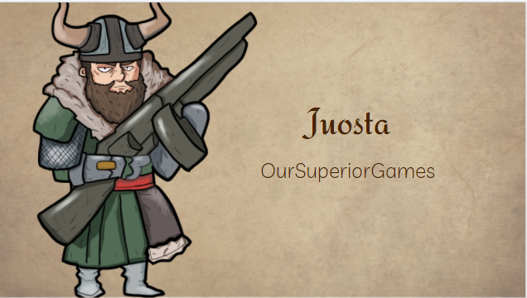

JUOSTA (meaning run in Finnish) is a 2D rouge-lite top-down bullet hell shooter set around the Norse Mythology and viking theme. The objective of the game is to escape to the final floor of the dungeon by traversing through the procedurally generated rooms filled with monsters and random events that would alter each playthrough.

The game also features a unique combat system that revolves around hitting monster’s vital points on top of an upgrade, lifeline and ultimate system (see Product Functions for more details) that rewards skilled players while also providing a safety net for beginners.

## Document Conventions (5%)

* **BOLD -** Game Title: **JUOSTA**
* *(ITALIC) -* Reference/Inspiration for Game Mechanic
* **BOLD** - Genre
* **BOLD** - Unique Selling Point

## Intended Audience and Reading Suggestions (Bonus : 1 Grade Scale for this section)

* Producer
  + Recommended Sequence:
    - Introduction Section
    - Overall Description
    - Appendix A
* Technical Director
  + Recommended Sequence:
    - External Interface Requirements
    - System Features Section
* Lead Designer
  + Recommended Sequence:
    - Introduction Section
    - Overall Description
    - External Interface Requirements
    - System Features
    - Appendix A, B, C
* Product & Test Manager
  + Recommended Sequence:
    - External Interface Requirement
    - System Features
    - Appendix B

## 

## References (10%)

***Some of the inspiration includes:***

* ***Streets of Rogue (Top-down Shooter Mechanics)***



* + [**https://store.steampowered.com/app/512900/Streets_of_Rogue/**](https://store.steampowered.com/app/512900/Streets_of_Rogue/)
* ***Binding of Isaac (Procedurally Generated Rooms)***
  + [**https://store.steampowered.com/app/250900/The_Binding_of_Isaac_Rebirth/**](https://store.steampowered.com/app/250900/The_Binding_of_Isaac_Rebirth/)
* ***Enter The Gungeon (Bullet Hell Aspect/ Boss Battles)***



* + [**https://store.steampowered.com/app/311690/Enter_the_Gungeon/**](https://store.steampowered.com/app/311690/Enter_the_Gungeon/)
* ***Jotun: Valhalla Edition (Norse Mythology and Vikings Theme)***
  + [**https://store.steampowered.com/app/323580/Jotun_Valhalla_Edition/**](https://store.steampowered.com/app/323580/Jotun_Valhalla_Edition/)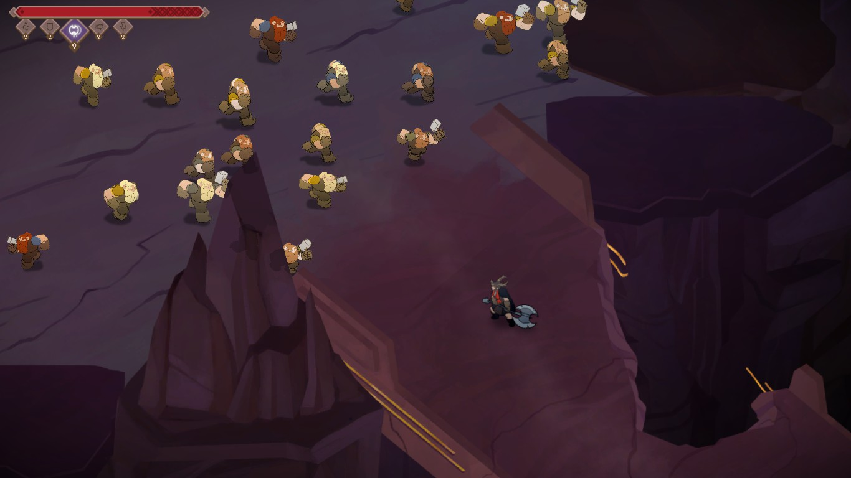
* ***Munchkin: The Original Card Game (Room Effects)***

* + ***[https://en.wikipedia.org/wiki/Munchkin_(card_game](https://en.wikipedia.org/wiki/Munchkin_(card_game))***[***)***](https://en.wikipedia.org/wiki/Munchkin_(card_game))

# 

# Overall Description (Section : 25%)

## Product Perspective (15%)

**JUOSTA** is inspired by **Top-Down** **Shooter** games such as *Streets Of Rogue*, *Binding Of Isaac* for its **Procedurally Generated Rooms**, *Enter the Gungeon* for its **Bullet Hell** features, *Munchkin* for its **Passive Room Effects**, and *Jotun* for the **Viking Theme**.

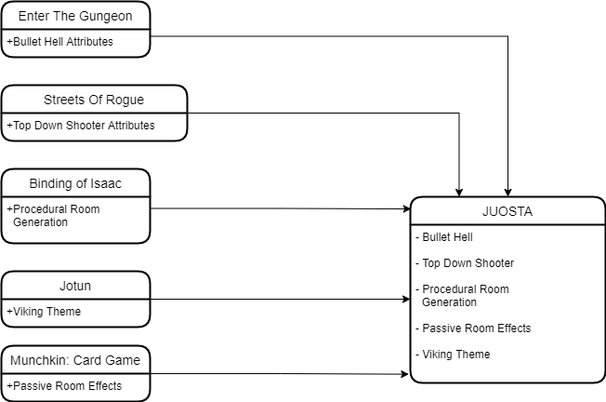

## 

## Product Functions (Bonus : 1 Grade Scale for this section)

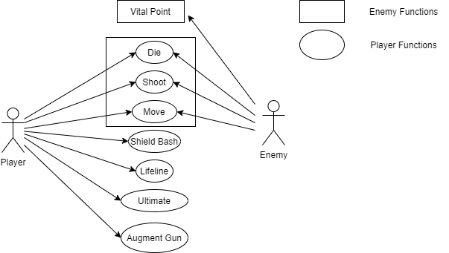

**Player Functions:**

* **Shooting Mechanic**
  + Needs to be able to at least shoot a projectile at enemies
* **Movement Mechanics**
  + Needs to be able to move in the game
* **Shield Bash Mechanic**
  + Needs to be able to perform a Dash and push back enemies
  + Enemies get stunned when the player bash into enemy vital points
* **Lifeline Mechanic**
  + A bar that increases when certain number of enemies are killed
  + When it is full, it will be used when Player original HP is empty
  + During Lifeline state, Player will have increased stats but only for a few seconds
  + If Player manages to kill any enemy mob, Player can then be revived
* **Player Ultimate Ability**
  + Player will have a Ultimate bar which increases after killing huge amount of enemies
  + When it is full, Player will trigger it by pressing Ultimate Button
  + When Ultimate gets activated, it will drop projectiles onto enemies head
  + When projectiles land onto enemies, it will spawn an AOE projectile that will damage nearby enemies
* **Player Death Mechanic**
  + Player dies when player has no more HP left

**Enemy Functions:**

* **Vital Points**
  + Enemy receive more damage if get hit at vital point
* **Shooting Mechanic**
  + Enemies get too shoot multiple projectiles at player in one shot
  + Shoot AOE attack on player
* **Enemy Movement Mechanics**
  + Uses Pathfinding to travel across the map
  + Sets player position as target
  + Avoids obstacles on map
* **Enemy Death Mechanic**
  + Enemy dies when enemy has no more HP left

## User Classes and Characteristics (5%)

**Targeted towards fans of**

* Dungeon-Crawler
* Bullet Hell
* Top Down Shooter
* Norse Mythology and Vikings

who wants to have a different challenge from the common style of these 4 genres.

## Assumptions and Dependencies (5%)

Third-Party Dependencies:

* Alpha Engine - Game Library
* Adobe Photoshop - Art Assets
* Open Broadcast Software - Gameplay Recording
* Unity - Prototyping
* Github Client - Source Control
* Jira - Task Management
* Fmod - Audio Library
* Tiles - Level Editor

# 

# External Interface Requirements (Section : 5%)

## User Interfaces (5%) MENUS

# System Features (Section : 40%)

## Game Controller

4.1.1 Description and Priority

Controls the flow of the game

* Priority: **HIGH**
* Benefit: 9
* Penalty: 9
* Cost: 1 Engine Programmer, 1 Gameplay Programmer
* Risk: 3

4.1.2 Stimulus/Response Sequences

* Player start up the application to play the game
* Player exit the application

4.1.3 Functional Requirements

* REQ-1: Able to start Initialize and Load the game (HIGH)
* REQ-2: Able to make the game flow (HIGH)
* REQ-3: Able to update game state (HIGH)
* REQ-4: Able to Exit Game (HIGH)

## Render Component

4.2.1 Description and Priority

Component to render all GameObjects on the screen

* Priority: **HIGH**
* Benefit: 9
* Penalty: 9
* Cost: 1 Engine Programmer
* Risk: 3

4.2.2 Stimulus/Response Sequences

* Player can see where the enemies are for the player to shoot at
* Player can see bullet flying across the room/map

4.2.3 Functional Requirements

* REQ-1: Needs to be able render sprites and quads on screen (HIGH)
* REQ-2: Needs to be able to set color of rendered objects (MEDIUM)
* REQ-3: Able to set alpha blending to transparent (HIGH)

## Transform Component

4.3.1 Description and Priority

Component to determine GameObject’s position, rotation and scale.

* Priority: **HIGH**
* Benefit: 9
* Penalty: 9
* Cost: 1 Engine Programmer
* Risk: 5

4.3.2 Stimulus/Response Sequences

* Player is able to see GameObjects move around the room/map using transformation

4.3.3 Functional Requirements

* REQ-1: Able to translate GameObject’s position using mtx33 and Vec2 (HIGH)
* REQ-2: Able to rotate GameObject using mtx33 and Vec2 (HIGH)
* REQ-3: Able to scale GameObject’s size using mtx33 and Vec2 (HIGH)
* REQ-4: Able to setup SceneGraph/GameObject Hierarchy for Game (MEDIUM)

## Behaviour Component

4.4.1 Description and Priority

Behaviour component holds the logic for GameObjects that requires logic

* Priority: **HIGH**
* Benefit: 9
* Penalty: 9
* Cost: 1 Engine Programmer, 1 Gameplay Programmer, 1 Playtest Manager
* Risk: 5

4.4.2 Stimulus/Response Sequences

* Player should be able to see how each GameObjects interact with one another

4.4.3 Functional Requirements

* REQ-1: Needs to handle gameplay logic (HIGH)
* REQ-2: Needs to be able to function like unity scripting (MEDIUM)
* REQ-3: Needs to be easy for other team members to use (HIGH)
* REQ-4: Needs to allow GameObjects to interact with one another (HIGH)
* REQ-5: Needs to be able to Get information from other Components (HIGH)

## Physics Component

4.5.1 Description and Priority

Component should provide the response of every force acting on every GameObject

* Priority: **MEDIUM**
* Benefit: 9
* Penalty: 5
* Cost: 1 Engine Programmer, 1 Gameplay Programmer
* Risk: 6

4.5.2 Stimulus/Response Sequences

* Players can see the projectiles accelerate
* Able to make player feel more immersed in the gameplay
* In-game Characters can get knocked back by projectile (TBC)

4.5.3 Functional Requirements

* REQ-1: Make Projectiles accelerate in game (MEDIUM)
* REQ-2: Make Characters get knocked back by projectile (LOW)(TBC)

## Collision Component

4.6.1 Description and Priority

Collision component is used to detect if there are any collisions happening, usually coupled with OnCollision event

* Priority: **HIGH**
* Benefit: 9
* Penalty: 9
* Cost: 1 Engine Programmer, 1 Playtest Manager
* Risk: 5

4.6.2 Stimulus/Response Sequences

* Players can see and feel the bullets hitting the enemy, vice versa.
* Players cannot walk past walls
* Players can activate events by collision

4.6.3 Functional Requirements

* REQ-1: Needs to have OnTriggerEnter and OnCollisionEnter (HIGH)
* REQ-2: Must support all Moving GameObjects (HIGH)

## Pathfinding

4.7.1 Description and Priority

Pathfinding is a component to allow Enemy AI to path towards player

* Priority: **MEDIUM**
* Benefit: 9
* Penalty: 7
* Cost: 1 Gameplay Programmer/ 1 Engine Programmer
* Risk: 7

4.7.2 Stimulus/Response Sequences

* Enemy can chase player around the room and attack
* Enemy avoid obstacles to reach player

4.7.3 Functional Requirements

* REQ-1: Need to follow target and avoid obstacle (MEDIUM)
* REQ-2: Need to be able to update target position in real time (MEDIUM)

## Procedural Map Generation System

4.8.1 Description and Priority

System should be able to generate rooms with random event effects

* Priority: **MEDIUM**
* Benefit: 9
* Penalty: 6
* Cost: 1 Gameplay Programmer, 1 Level Designer, 1 Playtest Manager
* Risk: 7

4.8.2 Stimulus/Response Sequences

* Prevent Player from feeling repetitive
* Forces Player to adopt different playstyles
* Player also needs to strategize their path to the end of the level
* Makes player want to replay again to discover more rooms and monsters

4.8.3 Functional Requirements

* REQ-1: Must be able to be generated from a few pre-designed room (HIGH)
* REQ-2: Each room needs to have its own unique stats modifiers (HIGH)
* REQ-3: Needs to increase number of rooms according to level (MEDIUM)
* REQ-4: The number of enemies must be balanced throughout the rooms (MEDIUM)

## Shield Bash

4.9.1 Description and Priority

Player character uses a shield and dash towards cursor, blocking incoming projectiles and bash enemy. If hit enemy vital, enemy get stunned.

* Priority: **HIGH**
* Benefit: 9
* Penalty: 9
* Cost: 1 Gameplay Programmer, 1 Playtest Manager
* Risk: 5

4.9.2 Stimulus/Response Sequences

* Player use shield bash to block damage from incoming projectiles
* Can be used to stun enemies if hit vital

4.9.3 Functional Requirements

* REQ-1: Must be able to Dash towards Cursor (HIGH)
* REQ-2: Must be able to block damage from all incoming Projectiles (HIGH)
* REQ-3: Can Stun Enemies if hit vital (LOW)
* REQ-4: Cooldown must be implemented (HIGH)
* REQ-5: Cannot shoot while Shield Bashing (HIGH)

## Lifeline System

4.10.1 Description and Priority

System to reward player for killing huge amounts of enemies in game

* Priority: **HIGH**
* Benefit: 9
* Penalty: 9
* Cost: 1 Gameplay Programmer, 1 Playtest Manager
* Risk: 7

4.10.2 Stimulus/Response Sequences

* Player can have a second chance to go further into the run if they killed large amount of enemies
* If lifeline bar is filled, the next time he dies, player revives on lifeline bar
* Once lifeline bar is finished, player will recover half of its max health
* Lifeline bar can only be filled by killing large amounts of monsters

4.10.3 Functional Requirements

* REQ-1: Must have a bar to indicate lifeline gauge (HIGH)
* REQ-2: Must be able to activate once the player dies and lifeline gauge is filled (HIGH)
* REQ-3: Must be able to allow player to recover a certain percentage of player max health after lifeline mode is over (HIGH)

## Shop/Upgrade/Gun Augments System

4.12.1 Description and Priority

System should render all the entities in the current game level

* Priority: **MEDIUM**
* Benefit: 9
* Penalty: 4
* Cost: 1 Gameplay Programmer, 1 Playtest Manager
* Risk: 7

4.12.2 Stimulus/Response Sequences

* Players will be able to buy potions in game
* Players will be able to augment their guns using the augment shop in the main menu
* Player needs to kill monsters to gain money
* If player dies, player gets to keep all gold and stats, but lose all gun augments
* Player must spend all gold in before going for another run, as they cannot carry over

4.12.3 Functional Requirements

* REQ-1: Must allow players to buy and equip augment guns if they have any (HIGH)

# 

# Appendix A: Glossary

*<Define all the terms necessary to properly interpret the SRS, including acronyms and abbreviations. You may wish to build a separate glossary that spans multiple projects or the entire organization, and just include terms specific to a single project in each SRS.>*

# Appendix B: Analysis Models

# 

# Appendix C: To Be Determined List

* Boss Room/Boss Battle
* Camera Shake
* Pure Procedural Map Generation
* Unique Enemy Attack Patterns
* Character On Hit Knockback